Practical 11 — Student Management CRUD with Search and Filtering

Aim
To let faculty create, read, update and delete student records with search, filters and pagination backed by MySQL.

Theory
CRUD concentrates all record mutations behind role checks, parameterised queries and escaped output, with search and paging keeping large lists usable.
- A single faculty management page of about 30 KB hosts the add form, search and filter bar, paged table and edit and delete actions.
- Search matches names and identifiers while course and status filters and sorting narrow the set; pagination slices it per page.
- Every write uses parameterised statements; every echoed value is escaped against scripting.
- A dedicated migration documents the indexes and constraints supporting this practical.
- Live list behaviour without reloads arrives in Practical 13; here the classic round-trip flow is the baseline.

Procedure
- Built the faculty student-management page with add, search, filter, sort, table, pager and row actions.
- Backed reads and writes with parameterised queries through the shared database files.
- Added the supporting migration for indexes and constraints.
- Inspected the management page and migration on disk; live mutation was not re-executed here without a server.
- Used project captures for the running proof and a fresh static capture for the list surface.

Screenshots
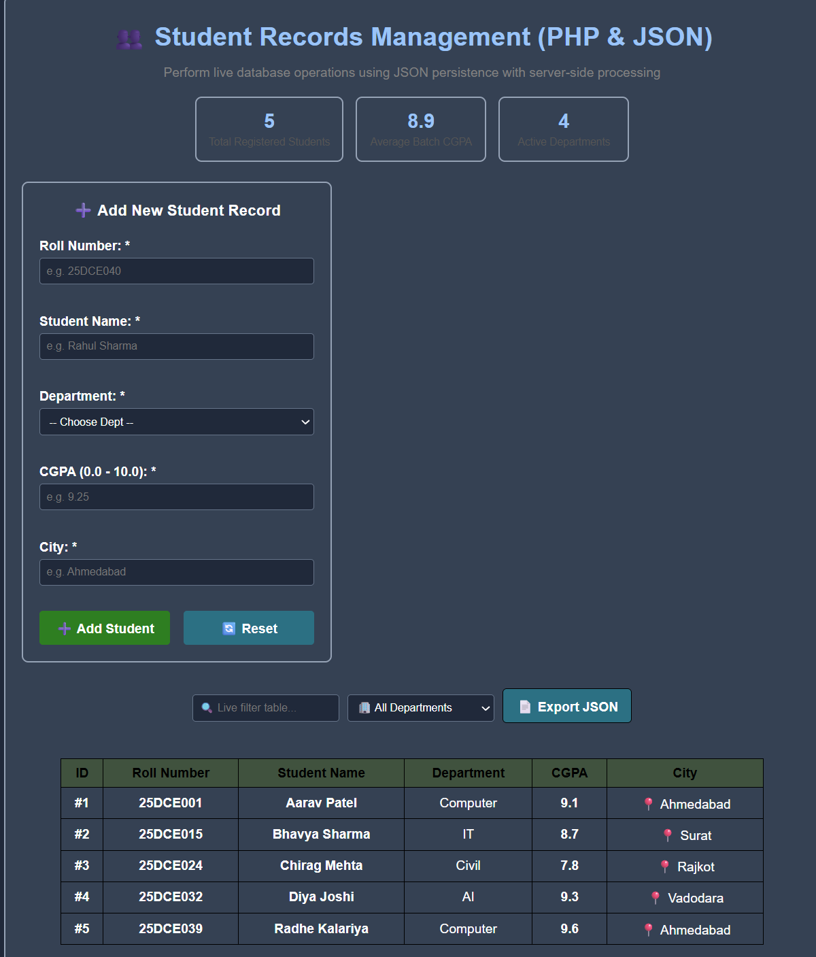

GitHub Repository Link
Practical repository : https://github.com/Rkpatel34/StudentHub/tree/main/studenthub

Conclusion
Practical 11 delivered the first full record lifecycle for students with safe queries and usable discovery.

